Assignment 1 –

Creating Table –

CREATE TABLE Studentinfo ( Roll INT, Name VARCHAR(50), Branch VARCHAR(50), Mobile VARCHAR(50), Total INT)

Inserting Data –

INSERT INTO Studentinfo VALUES

(101, 'Ayush', 'CSE', '1234567890', 78),

(102, 'Vrushal', 'ETC', '2345678901', 89),

(103, 'Prany', 'EE', '3456789012', 97),

(104, 'Yash', 'CSE', '4567890123', 65),

(105, 'Toshit', 'ETC', '5678901234', 88)

Display data –

SELECT * FROM Studentinfo;

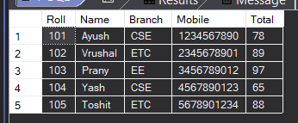

Que 1. Display record having total > 80 using View?

CREATE VIEW total_above_80 AS SELECT * FROM Studentinfo WHERE total > 80;

SELECT * FROM total_above_80;

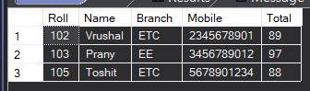

Que 2. Display Record where total is between 70 to 95

CREATE VIEW Bet_total AS SELECT * FROM Studentinfo WHERE total BETWEEN 70 AND 95

SELECT * FROM Bet_total

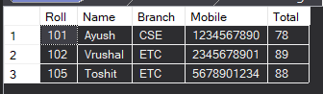

Que 3. Create view for group by branch

CREATE VIEW Group_branch AS SELECT branch FROM studentinfo GROUP BY branch;

SELECT * FROM Group_branch;

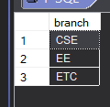

Que 4. Create view for descending Total

CREATE VIEW rollno_order AS SELECT * FROM studentinfo ORDER BY roll DESC;



CREATE VIEW D_studentinfo AS SELECT * FROM studentinfo;

SELECT * FROM D_studentinfo;

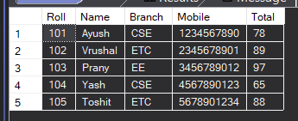

SELECT * FROM D_studentinfo ORDER BY total DESC;

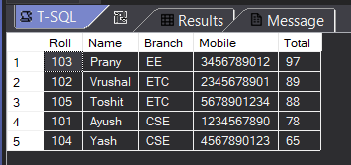

Que 5. Create view CSE and ETC branch

CREATE VIEW branch_in AS SELECT * FROM studentinfo WHERE branch IN ('CSE', 'ETC');

SELECT * FROM branch_in;

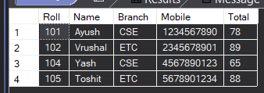

Que 6. Add new column as a primary key

ALTER TABLE Studentinfo ADD u_roll INT PRIMARY KEY;



ALTER TABLE Studentinfo ADD CONSTRAINT u_roll PRIMARY KEY (roll);

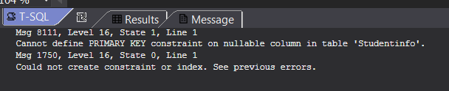

Que 7. Make unique key

ALTER TABLE studentinfo ADD CONSTRAINT u_roll UNIQUE (roll); 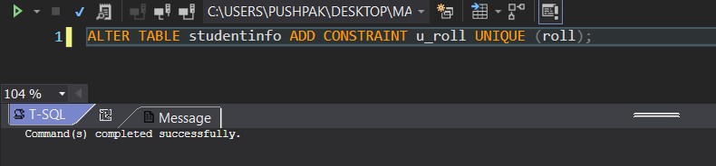

Assignment 3 –

Que 1. Insert data using store procedure

Insert Data –

CREATE PROCEDURE insertdata(@id1 AS INT,

@Name1 AS VARCHAR(50),

@Email1 AS VARCHAR(50),

@Mobile1 AS VARCHAR(50),

@Salary1 AS VARCHAR(50)

)

AS

BEGIN

INSERT INTO Employee (Id, Name, Email, Mobile, salary) VALUES (@id1, @Name1, @Email1, @Mobile1, @Salary1);

END;

SQL Query –

EXEC insertdata @Id1 = 101, @Name1 = 'Ayush', @Email1 = 'ayush@gmail.com', @Mobile1 = '1234567890', @Salary1 = 40000

EXEC insertdata @Id1 = 102, @Name1 = 'Vrushal', @Email1 = 'vrushal@gmail.com', @Mobile1 = '2345678901', @Salary1 = 50000

EXEC insertdata @Id1 = 103, @Name1 = 'Yash', @Email1 = 'vrushal@gmail.com', @Mobile1 = '3456789012', @Salary1 = 20000

EXEC insertdata @Id1 = 104, @Name1 = 'toshit', @Email1 = 'toshit@gmail.com', @Mobile1 = '4567890123', @Salary1 = 15000

EXEC insertdata @Id1 = 105, @Name1 = 'Chetan', @Email1 = 'chetan@gmail.com', @Mobile1 = '5678901234', @Salary1 = 65000

EXEC insertdata @Id1 = 106, @Name1 = 'nikhil', @Email1 = 'nikhil@gmail.com', @Mobile1 = '6789012345', @Salary1 = 59000

Output –

SELECT * FROM employee

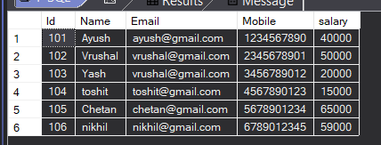

Que 2. Update using store procedure

Store procedure –

CREATE PROCEDURE update_data(

@id1 AS INT,

@Name1 AS VARCHAR(50),

@Email1 AS VARCHAR(50),

@Mobile1 AS VARCHAR(50),

@Salary1 AS int

)

AS

BEGIN

UPDATE Employee SET Name = @Name1, Email = @Email1, Mobile = @Mobile1 , salary = @Salary1 WHERE Id = @id1;

END;

SQL query –

EXEC update_data @id1 = 101, @Name1 = 'Mohan', @Email1 = 'Mohan@gmail.com', @Mobile1 = '9988776655', @Salary1 = 99999;

Output –

SELECT * FROM Employee

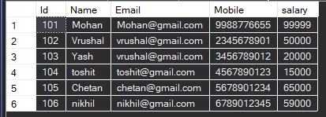

Update only Name

Store Procedure –

CREATE PROCEDURE update_name(

@id1 AS INT,

@Name1 AS VARCHAR(50)

)

AS

BEGIN

UPDATE employee SET Name = @Name1 WHERE Id = @id1;

END;

SQL Query –

EXEC update_name @id1 = 103, @Name1 = 'Pranay'

Output –

SELECT * FROM Employee

